Access to Information and Attitudes towards Intimate Partner Violence

In this exercise, we examine cross-national differences in attitudes towards domestic violence and access to information. We explore the hypothesis that there is an association at an aggregate level between the extent to which individuals in a country have access to knowledge and new information, both through formal schooling and through the mass media, and their likelihood of condemning acts of intimate partner violence. This exercise is in part based on:

Pierotti, Rachel. (2013). “[Increasing Rejection of Intimate Partner Violence: Evidence of Global Cultural Diffusion](http://dx.doi.org/10.1177/0003122413480363).” *American Sociological Review*, 78: 240-265.

We use data from the Demographic and Health Surveys, which are a set of over 300 nationally, regionally and residentially representative surveys that have been fielded in developing countries around the world, beginning in 1992. The surveys employ a stratified two-stage cluster design. In the first stage enumeration areas (EA) are drawn from Census files. In the second stage within each EA a sample of households is drawn from an updated list of households. In addition, the surveys have identical questionnaires and trainings for interviewers, enabling the data from one country to be directly compared with data collected in other countries. It is important to note that different groups of countries are surveyed every year.

In the study, the author used these data to show that “women with greater access to global cultural scripts through urban living, secondary education, or access to media were more likely to reject intimate partner violence.” The data set is in the csv file dhs_ipv.csv. The names and descriptions of variables are:

|  |  |
| --- | --- |
| Name CUDJOE SMITH | Description IN CLASS ASSIGNMENT 5. |
| beat_goesout | Percentage of women in each country that think a husband is justified to beat his wife if she goes out without telling him. |
| beat_burnfood | Percentage of women in each country that think a husband is justified to beat his wife if she burns his food. |
| no_media | Percentage of women in each country that rarely encounter a newspaper, radio, or television. |
| sec_school | Percentage of women in each country with secondary or higher education. |
| year | Year of the survey |
| region | Region of the world |
| country | Country |

Note that there are two indicators of *attitudes towards domestic violence*: beat_goesout and beat_burnfood. There are also two indicators of *access to information*: sec_school and no_media.

## Question 1

Let’s begin by examining the association between attitudes towards intimate partner violence and the two exposure to information variables in our data. Load the dhs_ipv.csv data set. Use scatterplots to examine the bivariate relationship between beat_goesout and no_media as well as between beat_goesout and sec_school. Repeat these bivariate graphs between beat_burnfood and no_media, as well as beat_burnfood and sec_school. Be sure to add informative axis labels. Briefly interpret these graphs in light of the hypothesis of the study.

## Answer 1

M_data <- read.csv("dhs_ipv 2.csv")  
attach(M_data)#Attach data set  
summary(M_data)

## X beat_burnfood beat_goesout sec_school   
## Min. : 1.00 Min. : 0.10 Min. : 0.30 Min. : 3.10   
## 1st Qu.: 40.50 1st Qu.: 4.50 1st Qu.:11.85 1st Qu.:10.18   
## Median : 79.00 Median :11.85 Median :28.10 Median :22.40   
## Mean : 80.53 Mean :15.04 Mean :28.60 Mean :24.40   
## 3rd Qu.:119.50 3rd Qu.:22.25 3rd Qu.:42.08 3rd Qu.:34.90   
## Max. :160.00 Max. :64.50 Max. :82.70 Max. :74.60   
## NA's :31 NA's :27 NA's :3   
## no_media country year region   
## Min. : 0.80 Length:151 Min. :1999 Length:151   
## 1st Qu.:11.25 Class :character 1st Qu.:2004 Class :character   
## Median :29.15 Mode :character Median :2007 Mode :character   
## Mean :28.40 Mean :2007   
## 3rd Qu.:43.23 3rd Qu.:2011   
## Max. :86.40 Max. :2014   
## NA's :13

# To show the relationship between beat_goesout and no_media  
plot(no_media,beat_goesout,   
 main = "Scatterplot",   
 ylab = "beat_goesout",   
 xlab = "no media")

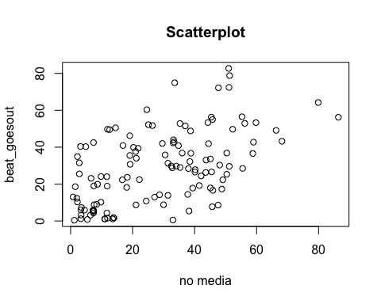

# This figure is a scatter plot showing the relationship between the percentages of women in each country who think a husband is justified to hit his wife if she goes out without telling him (beat_goesout) and the percentage of women in each country that rarely encounter a newspaper, radio or television (no_media). The graph shows a positive relationship between beat_goesout and no_media meaning as the percentage of women in each country that rarely encounter a newspaper, radio or television increases, the percentages of women in each country who think a husband is justified to hit his wife if she goes out without telling him increases.  
  
#To show the relationship between beat_goesout and sec_school  
plot(sec_school,beat_goesout,   
 main = "Scatterplot",  
 ylab = "beat_goesout",   
 xlab = "Sec_school",   
 col = 2)

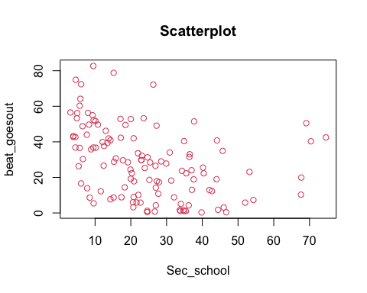

# This figure is a scatter plot showing the relationship between the percentages of women in each country who think a husband is justified to hit his wife if she goes out without telling him (beat_goesout) and the percentage of women who have secondary or higher level of education (Sec_school). The graph shows a negative relationship between beat_goesout and Sec_school meaning as the percentage of women who have secondary or higher level of education increases, the percentages of women who think a husband is justified to hit his wife for burning his food decreases.  
  
  
#To show the relationship between beat_burnfood and no_media  
plot(no_media,beat_burnfood,   
 main = "Scatterplot",   
 ylab = "beat_burnfood",   
 xlab = "no_media",  
 col = 3)

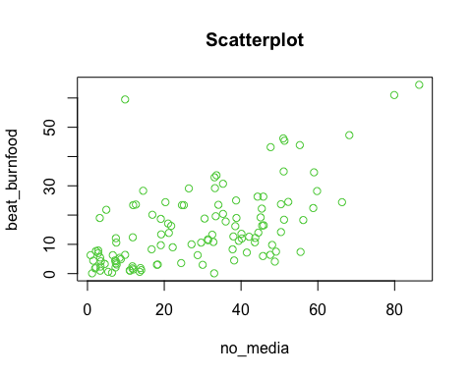

# This figure is a scatter plot showing the relationship between the percentages of women in each country who think a husband is justified to hit a wife for burning his food (beat_burnfood) and the percentage of women in each country that rarely encounter a newspaper, radio or television (no_media). The graph shows a positive relationship between (beat_burnfood) and (no_media) meaning as the percentage of women in each country that rarely encounter a newspaper, radio or television increases , the percentages of women who think a husband is justified to hit his wife for burning his food increases.  
  
#To show the relationship between beat_burnfood and sec_school  
plot(sec_school,beat_burnfood,  
 main = "Scatterplot",   
 ylab = "beat_burnfood",   
 xlab = "Sec_school",   
 col = 4)

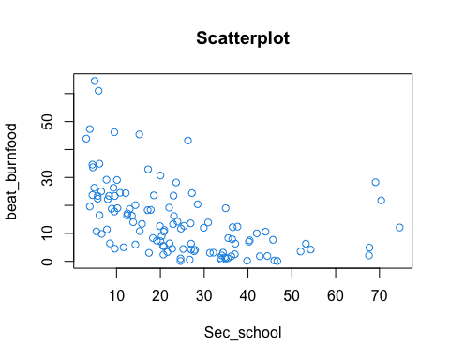

# This figure is a scatter plot showing the relationship between the percentages of women who think a husband is justified to hit his wife for burning his food (beat_burnfood) and the percentage of women who have secondary or higher level of education (Sec_school). The graph shows a negative relationship between beat_burnfood and Sec_school meaning as the percentage of women who have secondary or higher level of education increases, the percentages of women who think a husband is justified to hit his wife for burning his food decreases.

## Question 2

Compute the correlation coefficient between beat_burnfood and media exposure, as well as between beat_burnfood and education. Remember to use complete observations. What do these measures tell us about the association between education and media exposure with attitudes towards intimate partner violence?

## Answer 2

#Correlation coefficient between burnfood and media exposure  
na.omit(M_data)

## X beat_burnfood beat_goesout sec_school no_media  
## 1 1 4.4 18.6 25.2 1.5  
## 2 4 4.9 19.9 67.7 8.7  
## 3 5 2.1 10.3 67.6 2.2  
## 4 6 0.3 3.1 46.0 6.4  
## 5 7 12.1 42.5 74.6 7.4  
## 8 10 4.1 17.3 27.9 48.8  
## 9 11 29.2 44.0 7.7 33.2  
## 10 12 19.0 36.7 10.2 38.8  
## 11 13 6.0 7.7 14.3 45.7  
## 12 14 5.4 9.0 20.8 8.4  
## 13 15 3.3 5.9 21.6 4.5  
## 14 16 26.3 53.3 4.9 44.3  
## 15 17 9.8 30.3 6.6 48.1  
## 16 18 25.0 48.8 6.5 38.7  
## 20 22 13.3 29.8 22.9 32.5  
## 21 23 11.7 31.3 24.7 31.4  
## 22 24 19.2 33.6 22.0 45.1  
## 23 25 13.6 26.5 26.9 40.1  
## 28 30 12.7 28.4 25.4 38.0  
## 32 34 28.2 53.3 23.6 59.8  
## 33 35 24.4 49.1 27.2 66.3  
## 35 37 16.4 26.6 12.4 45.5  
## 36 38 2.4 3.2 20.7 3.4  
## 37 39 1.0 1.2 24.6 3.3  
## 38 40 0.6 0.8 26.7 5.4  
## 41 43 19.0 40.4 34.9 3.2  
## 42 44 7.9 31.5 36.4 2.8  
## 43 45 7.0 25.5 40.2 2.8  
## 44 46 29.1 51.7 10.1 26.4  
## 45 47 64.5 56.2 5.0 86.4  
## 46 48 61.0 64.2 5.9 79.9  
## 47 49 47.3 43.2 3.9 68.2  
## 49 51 10.6 19.0 44.0 7.5  
## 50 52 10.6 42.0 20.8 29.6  
## 51 53 13.9 34.0 30.9 21.2  
## 52 54 8.3 22.3 35.5 16.7  
## 53 55 34.9 72.4 6.1 51.1  
## 54 56 46.2 82.7 9.5 51.0  
## 56 58 3.5 5.8 52.0 7.4  
## 57 59 10.8 28.8 15.3 32.8  
## 58 60 9.0 22.4 20.3 22.2  
## 59 61 3.6 10.8 27.7 24.4  
## 60 62 5.5 6.0 20.6 3.3  
## 61 63 4.2 4.3 27.0 7.4  
## 62 64 20.4 29.0 28.5 35.3  
## 63 65 3.0 18.2 31.3 18.1  
## 64 66 3.1 23.7 34.3 18.3  
## 65 67 2.5 24.0 37.0 11.7  
## 67 69 7.7 34.9 45.7 2.2  
## 69 71 1.8 12.3 42.7 2.0  
## 70 72 16.3 39.4 13.5 21.8  
## 71 73 13.4 30.7 15.8 19.2  
## 72 74 6.3 23.1 53.2 6.6  
## 73 75 12.6 24.4 19.9 42.1  
## 74 76 6.3 14.2 27.0 28.7  
## 75 77 14.0 41.9 13.8 44.5  
## 76 79 7.4 28.5 19.2 55.5  
## 77 80 8.3 14.4 18.3 37.8  
## 78 81 7.2 19.2 20.0 41.5  
## 79 84 16.5 16.6 6.1 45.9  
## 80 85 11.4 13.9 7.8 31.4  
## 81 86 4.5 5.4 9.6 38.2  
## 82 88 6.3 13.0 37.1 0.8  
## 83 89 33.6 74.9 4.6 33.6  
## 84 90 23.4 60.3 5.7 24.6  
## 85 91 26.3 55.0 9.3 45.8  
## 87 93 4.2 7.3 54.3 3.5  
## 88 94 23.6 49.5 18.5 12.6  
## 89 95 23.7 36.8 4.5 50.4  
## 91 97 6.4 8.6 8.5 47.6  
## 93 99 12.4 18.9 37.6 11.8  
## 94 100 10.0 12.9 42.0 27.1  
## 96 102 3.0 8.8 17.4 30.0  
## 97 103 0.1 0.5 24.6 33.0  
## 98 104 4.5 5.8 22.7 7.2  
## 99 105 43.9 56.5 3.1 55.3  
## 100 106 34.6 42.7 4.5 59.0  
## 101 107 30.7 52.8 20.0 35.3  
## 102 108 16.2 32.2 23.1 38.5  
## 104 110 14.2 25.3 23.9 50.4  
## 106 112 18.4 29.6 17.8 51.2  
## 108 114 0.6 1.1 33.9 13.6  
## 109 115 1.2 1.6 33.7 14.0  
## 110 116 1.9 1.8 44.4 13.8  
## 111 117 1.4 1.5 34.7 11.9  
## 112 118 1.0 1.1 34.9 11.1  
## 113 119 1.1 1.1 35.4 11.0  
## 114 120 3.1 8.8 32.1 7.6  
## 115 121 2.1 5.1 34.0 7.3  
## 116 122 1.8 4.3 36.2 11.7  
## 117 123 22.4 36.6 5.7 58.8  
## 118 124 10.7 26.3 5.4 43.6  
## 119 125 18.8 35.8 8.9 30.5  
## 120 127 6.4 10.2 22.1 9.8  
## 121 128 23.4 49.7 8.3 11.9  
## 122 131 24.4 39.9 12.1 20.3  
## 123 132 18.7 46.2 13.0 19.1  
## 124 133 20.1 40.9 14.3 16.9  
## 125 134 24.5 49.7 10.8 52.3  
## 126 135 18.3 52.9 17.1 56.2  
## 127 136 28.3 50.5 69.1 14.5  
## 129 138 19.6 42.8 3.9 33.4  
## 131 140 17.8 36.8 9.5 36.0  
## 133 142 43.2 72.2 26.3 47.7  
## 134 143 11.2 17.8 20.9 39.4  
## 135 144 21.8 40.3 70.4 4.9  
## 136 145 22.2 56.3 8.0 45.4  
## 138 147 23.4 52.2 9.6 25.1  
## 141 150 17.1 37.7 12.5 21.0  
## 142 151 0.1 0.4 46.7 1.2  
## 146 155 45.4 78.8 15.2 51.3  
## 147 156 32.9 42.3 17.2 33.1  
## 148 157 23.5 29.7 23.0 34.1  
## 149 158 12.0 27.8 29.9 40.2  
## 150 159 12.2 33.0 36.5 43.7  
## 151 160 7.5 22.3 40.4 49.1  
## country year region  
## 1 Albania 2008 Middle East and Central Asia  
## 2 Armenia 2000 Middle East and Central Asia  
## 3 Armenia 2005 Middle East and Central Asia  
## 4 Armenia 2010 Middle East and Central Asia  
## 5 Azerbaijan 2006 Middle East and Central Asia  
## 8 Bangladesh 2011 Asia  
## 9 Benin 2001 Sub-Saharan Africa  
## 10 Benin 2006 Sub-Saharan Africa  
## 11 Benin 2011 Sub-Saharan Africa  
## 12 Bolivia 2003 Latin America  
## 13 Bolivia 2008 Latin America  
## 14 Burkina Faso 2003 Sub-Saharan Africa  
## 15 Burkina Faso 2010 Sub-Saharan Africa  
## 16 Burundi 2010 Sub-Saharan Africa  
## 20 Cambodia 2010 Asia  
## 21 Cambodia 2014 Asia  
## 22 Cameroon 2004 Sub-Saharan Africa  
## 23 Cameroon 2011 Sub-Saharan Africa  
## 28 Comoros 2012 Latin America  
## 32 Congo Democratic Republic 2007 Sub-Saharan Africa  
## 33 Congo Democratic Republic 2013 Sub-Saharan Africa  
## 35 Cote d'Ivoire 2011 Sub-Saharan Africa  
## 36 Dominican Republic 2002 Latin America  
## 37 Dominican Republic 2007 Latin America  
## 38 Dominican Republic 2013 Latin America  
## 41 Egypt 2005 Middle East and Central Asia  
## 42 Egypt 2008 Middle East and Central Asia  
## 43 Egypt 2014 Middle East and Central Asia  
## 44 Eritrea 2002 Sub-Saharan Africa  
## 45 Ethiopia 2000 Sub-Saharan Africa  
## 46 Ethiopia 2005 Sub-Saharan Africa  
## 47 Ethiopia 2011 Sub-Saharan Africa  
## 49 Gabon 2012 Sub-Saharan Africa  
## 50 Gambia 2013 Sub-Saharan Africa  
## 51 Ghana 2003 Sub-Saharan Africa  
## 52 Ghana 2008 Sub-Saharan Africa  
## 53 Guinea 2005 Sub-Saharan Africa  
## 54 Guinea 2012 Sub-Saharan Africa  
## 56 Guyana 2009 Latin America  
## 57 Haiti 2000 Latin America  
## 58 Haiti 2005 Latin America  
## 59 Haiti 2012 Latin America  
## 60 Honduras 2005 Latin America  
## 61 Honduras 2011 Latin America  
## 62 India 2005 Asia  
## 63 Indonesia 2002 Asia  
## 64 Indonesia 2007 Asia  
## 65 Indonesia 2012 Asia  
## 67 Jordan 2007 Middle East and Central Asia  
## 69 Jordan 2012 Middle East and Central Asia  
## 70 Kenya 2003 Sub-Saharan Africa  
## 71 Kenya 2008 Sub-Saharan Africa  
## 72 Kyrgyz Republic 2012 Middle East and Central Asia  
## 73 Lesotho 2004 Sub-Saharan Africa  
## 74 Lesotho 2009 Sub-Saharan Africa  
## 75 Liberia 2007 Sub-Saharan Africa  
## 76 Liberia 2013 Sub-Saharan Africa  
## 77 Madagascar 2003 Sub-Saharan Africa  
## 78 Madagascar 2008 Sub-Saharan Africa  
## 79 Malawi 2000 Sub-Saharan Africa  
## 80 Malawi 2004 Sub-Saharan Africa  
## 81 Malawi 2010 Sub-Saharan Africa  
## 82 Maldives 2009 Asia  
## 83 Mali 2001 Sub-Saharan Africa  
## 84 Mali 2006 Sub-Saharan Africa  
## 85 Mali 2012 Sub-Saharan Africa  
## 87 Moldova 2005 Middle East and Central Asia  
## 88 Morocco 2003 Middle East and Central Asia  
## 89 Mozambique 2003 Sub-Saharan Africa  
## 91 Mozambique 2011 Sub-Saharan Africa  
## 93 Namibia 2006 Sub-Saharan Africa  
## 94 Namibia 2013 Sub-Saharan Africa  
## 96 Nepal 2006 Asia  
## 97 Nepal 2011 Asia  
## 98 Nicaragua 2001 Latin America  
## 99 Niger 2006 Sub-Saharan Africa  
## 100 Niger 2012 Sub-Saharan Africa  
## 101 Nigeria 2003 Sub-Saharan Africa  
## 102 Nigeria 2008 Sub-Saharan Africa  
## 104 Nigeria 2013 Sub-Saharan Africa  
## 106 Pakistan 2012 Asia  
## 108 Peru 2004 Latin America  
## 109 Peru 2007 Latin America  
## 110 Peru 2009 Latin America  
## 111 Peru 2010 Latin America  
## 112 Peru 2011 Latin America  
## 113 Peru 2012 Latin America  
## 114 Philippines 2003 Asia  
## 115 Philippines 2008 Asia  
## 116 Philippines 2013 Asia  
## 117 Rwanda 2000 Sub-Saharan Africa  
## 118 Rwanda 2005 Sub-Saharan Africa  
## 119 Rwanda 2010 Sub-Saharan Africa  
## 120 Sao Tome and Principe 2008 Sub-Saharan Africa  
## 121 Senegal 2005 Sub-Saharan Africa  
## 122 Senegal 2010 Sub-Saharan Africa  
## 123 Senegal 2012 Sub-Saharan Africa  
## 124 Senegal 2014 Sub-Saharan Africa  
## 125 Sierra Leone 2008 Sub-Saharan Africa  
## 126 Sierra Leone 2013 Sub-Saharan Africa  
## 127 Tajikistan 2012 Sub-Saharan Africa  
## 129 Tanzania 2004 Sub-Saharan Africa  
## 131 Tanzania 2010 Sub-Saharan Africa  
## 133 Timor-Leste 2009 Asia  
## 134 Togo 2013 Sub-Saharan Africa  
## 135 Turkmenistan 2000 Middle East and Central Asia  
## 136 Uganda 2000 Sub-Saharan Africa  
## 138 Uganda 2006 Sub-Saharan Africa  
## 141 Uganda 2011 Sub-Saharan Africa  
## 142 Ukraine 2007 Asia  
## 146 Zambia 2001 Sub-Saharan Africa  
## 147 Zambia 2007 Sub-Saharan Africa  
## 148 Zambia 2013 Sub-Saharan Africa  
## 149 Zimbabwe 1999 Sub-Saharan Africa  
## 150 Zimbabwe 2005 Sub-Saharan Africa  
## 151 Zimbabwe 2010 Sub-Saharan Africa

m_da <- na.omit(M_data)  
cor(m_da$no_media,m_da$beat_burnfood)

## [1] 0.6568545

#Correlation coefficient between burnfood and sec_school  
cor(m_da$sec_school,m_da$beat_burnfood)

## [1] -0.4787731

#The correlation coefficient between beat_burnfood and no_media exposure is 0.66. This means there is a positive relationship between media exposure and the percentage of women in each country that think a husband is justified to beat his wife if she burns his food. Elaborating further, if the percentage of women in each country who rarely encounter a newspaper, radio, or television increases, it impacts the women with such beliefs as it continues to keep them into holding to that belief, since they become limited to any form of education they get from the media.  
  
#The correlation coefficient between beat_burnfood and education is -0.48. This means there is a weak negative relationship between education and the percentage of women in each country that think a husband is justified to beat his wife if she burns his food. Elaborating further, if the percentage of women with secondary or higher education increases, it impacts negatively the women with such beliefs as it continues to keep them into holding to that belief, since they become limited to any form of education they get from the media.

## Question 3

We proceed to explore the national-level differences in attitudes towards domestic violence. First, use boxplots to compare the variation in the percentage of beat_burnfood between different regions of the world using region. What are the main differences across regions in terms of the median and dispersion of the distribution? Second, using boxplots examine the distribution of no_media and sec_school by region of the world. Comment on the main differences of the distribution of these variables across regions.

## Answer 3

#Using boxplot to show the variations in beat_burnfood and region  
boxplot(m_da$beat_burnfood ~ m_da$region, main = "Boxplot by region")

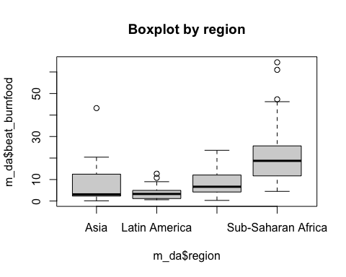

# From this figure, Asia has median of around 5%, Latin America 5%, Middle East and Central Asia 8% and Sub Saharan Africa 20%. Also Sub Saharan Africa has the maximum value (48%) across the regions. Sub Saharan Africa has the highest percentage of women who think a husband is justified to hit his wife for burning his food.  
  
#Using boxplot to show the variations in sec_school and region  
boxplot(m_da$sec_school ~ m_da$region, main = "Boxplot by region",ylab = "sec_school", xlab = "region")

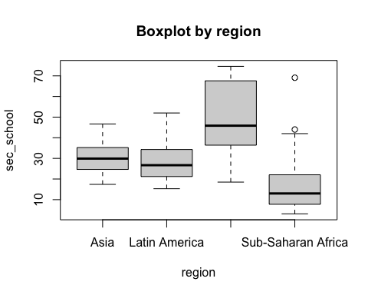

# From this figure, Middle East and Central Asia has the largest median value (43%) and a maximum value of 75% across the regions which means a fair number of them have attained secondary or higher education whereas Sub-Saharan Africa has the least median value of women who have attained secondary or higher education.  
  
#Using boxplot to show the variations in no_media and region  
boxplot(m_da$no_media ~ m_da$region, main = "Boxplot by region",ylab = "no_media",xlab = "region")

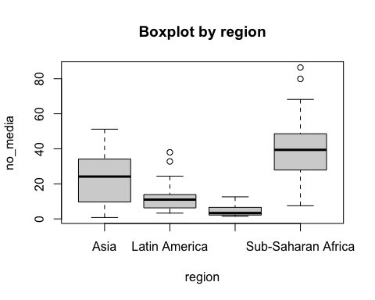

# From this figure, Sub-Saharan Africa has the largest median value (40%) and a maximum value of 70% across the regions which means a fair number of them rarely have encountered radio, newspaper or television whereas , Middle East and Central Asia has the least median value of women who have rarely have encountered radio, newspaper or television.

## Question 4

An important point of the researcher’s hypothesis is that the support towards intimate partner violence should *decrease* over time, as more women across regions have access to formal schooling and exposure to mass media. To test this idea, using time-series plots, examine the trends in beat_burnfood from 1999-2014 *within each region*. Thinking about the study design, what should we consider before trusting that this plot shows a change over time in attitudes?

## Answer 4

#Plotting the line graph to show the trend  
plot(year,beat_burnfood, type = "l", xlim = c(1998,2015), ylim = c(0,100))

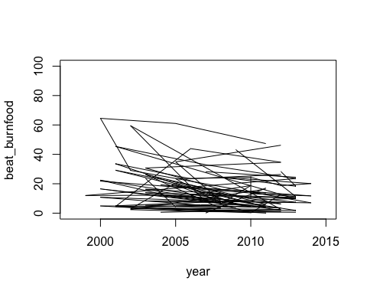

plot(year, type = "l")

